Assignment module 3 : Understanding and Maintenance of Networks
- What is the primary function of a router in a computer network?
Ans. Forwarding data packets between networks
- What is the purpose of DNS (Domain Name System) in a computer network?
Ans. Converting domain names to IP addresses
- What type of network topology uses a centralized hub or switch to connect all devices?
Ans. Star
- Which network protocol is commonly used for securely accessing and transferring files over a network?
Ans. FTP
- True or False: A firewall is a hardware or software-based security system that monitors and controls incoming and outgoing network traffic based on predetermined security rules.
Ans. True
- True or False: DHCP (Dynamic Host Configuration Protocol) assigns static IP addresses to network devices automatically.
Ans. False
- True or False: VLANs (Virtual Local Area Networks) enable network segmentation by dividing a single physical network into multiple logical networks.
Ans. True
- Explain the difference between a hub and a switch in a computer network.
Ans. A hub and a switch both connect multiple devices in a network, but they work differently:
Feature | Hub | Switch
Data transmission | Broadcast to all devices | Unicast to the intended device
Speed | Slower | Faster
Security | Low | High
OSI Layer | Layer 1 | Layer 2
Switches are more advanced and preferred over hubs in modern networks.
- Describe the process of troubleshooting network connectivity issues.
Ans. Troubleshooting network connectivity issues involves a systematic step-by-step approach to identify and fix the problem. Here is a clear process:
1 : Check Physical Connections
2: Verify Device Networks Settings
3 : Test Network Connectivity
4 : Restart Network Devices
5 : Check Hardware Network
6 : Check Firewall/ Security Settings
7 : Reset Network configuration
- Demonstrate how to configure a wireless router's security settings to enhance network security.
Ans. Steps to Configure Wireless Router Security Settings
- Access The Router Login Page
- Connect To Your Router
- Open A Web Browser
- Enter Router IP Address
- Log In To The Router
- Change Default Admin Username & Password
- Enable WPA3 or WPA2-PSK Encryption
- Select Security Mode
WPA3-Personal best
OR
WPA2-PSK
- Set a Strong Password
- Disable WPS
- Change WI-FI Network Name (SSID)
- Enable Router Firewall
- Update Router Firmware
- Discuss the importance of network documentation and provide examples of information that should be documented.
Ans. Network Documentation Is Essential For Managing, Maintaining, And Troubleshooting A Computer Network Efficiently. It Involves Keeping Detailed Records Of Network Components, Configurations, And Connections.
- Importance of Network Documentation
- Better Troubleshooting
- Efficient Network Management
- Consistency & Reliability
- Security Improvement
- Easy Onboarding for new Admin
- Disaster Recovery
In short, Good Documentation saves time, reduce errors, and protect the network.
- Examples of Information to document
- Network Topology
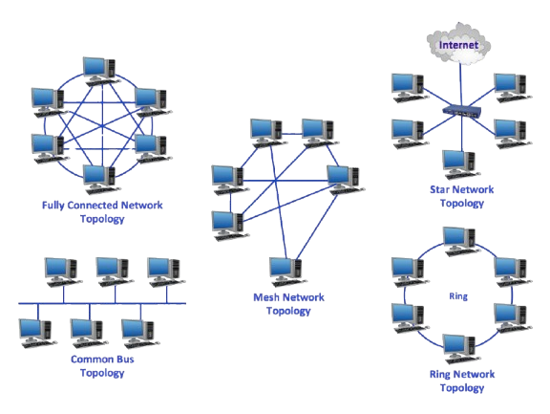
- IP Addressing
- IP Table (Device name, IP, Subnet, Gateway)
- Device Inventory
- Router, Switches, Servers, PCs, Printer Etc.
- Login Credentials (Secured)
- Configuration Files
- Router, Firewall, Switch Configuration.
- Network Policies
- Security Rules, Firewall Rules, Access Policies
- Software and License Info
- Cables and ports
- Cables Types, Port Numbers, Patch Panel Mapping
- Maintenance Logs
- Repairs, Updates, backups.

